zEnantioselective α-C-H Functionalization of Amides with Indoles Triggered by Radical Trifluoromethylation of Alkenes: Highly Selective Formation of C-CF3 and C-C Bonds

Taotao Li,[a,b] Peng Yu,[b] Yi-Meng Du,[b] Jin-Shun Lin,[b] Yonggang Zhi,*[a]and Xin-Yuan Liu*[b]

*a Chengdu Institute of Organic Chemistry, Chinese Academy of Sciences, Chengdu, 610041, P. R. China, University of Chinese Academy of Sciences, Beijing, 10004, P. R. China*

*b Department of Chemistry, South University of Science and Technology, Shenzhen, 518055, P. R. China*

E-mail: [**liuxy3@sustc.edu.cn**](mailto:liuxy3@sustc.edu.cn);[**zhiyonggang@cioc.ac.cn**](mailto:zhiyonggang@cioc.ac.cn)

**Table of Contents**

General information…………………………………………………………………S2

Experiments for mechanistic studies………………………………………………..S3

Synthetic Procedures and Spectral Data for Indoles……………………….........….S4

References…………………………………………………………………………..S12

NMR Spectra of New Compounds……………………………………………........S13

HPLC Spectra.………………………………………………………………...……S27

**General information**

All reactions were carried out under argon atmosphere using Schlenk techniques. Reagents were purchased at the highest commercial quality and used without further purification, unless otherwise stated. Chiral phosphoric acid (**CPA**) was purchased from Daicel Chiral Technologies (China). Analytical thin layer chromatography (TLC) was performed on precoated silica gel 60 GF254 plates. Flash column chromatography was performed using Tsingdao silica gel (60, particle size 0.040-0.063 mm). Visualization on TLC was achieved by use of UV light (254 nm) or iodine. NMR spectra were recorded on Bruker DRX-500 and DPX 400 spectrometer at 400 or 500 MHz for 1H NMR, 100 or 126 MHz for 13C NMR and 376 MHz for 19F NMR in CDCl3 with tetramethylsilane (TMS) as internal standard. The chemical shifts are expressed in ppm and coupling constants are given in Hz. Data for 1H NMR are recorded as follows: chemical shift (ppm), multiplicity (s, singlet; d, doublet; t, triplet; q, quarter; p, pentet, m, multiplet; br, broad), coupling constant (Hz), integration. Data for 13C NMR are reported in terms of chemical shift (δ, ppm). Melting points (mp) were recorded using SGW X-4A. IR spectroscopy was performed with a SHIMADZU Fourier Transform Infrared spectrophotometer IRPrestige-21 from 4000 cm-1 to 400 cm-1. Mass spectrometric data were obtained using Bruker Apex IV RTMS. Enantiomeric excess (ee) was determined using Agilent high-performance liquid chromatography (HPLC) with a Hatachi detector (λ = 254 or 214 nm). Column conditions are reported in the experimental section below.

**Experiments for mechanistic studies**

**Control experiments in the presence of radical scavengers**

Under argon, an oven-dried resealable Schlenk tube equipped with a magnetic stir bar was charged with amide substrate **1a** (0.05 mmol, 1.0 equiv), CuSCN (0.9 mg, 0.0075 mmol, 15 mol%), chiral phosphoric acid (**A1**) (4.3 mg, 0.005 mmol, 10 mol%), Togni’s reagent **2a** (26.9 mg, 0.085 mmol, 1.7 equiv), 2,2,6,6-tetramethyl-1-piperidinyloxy (TEMPO, 13.3 mg, 0.085 mmol, 1.7 equiv) or 2,6-di-*tert*-butyl-4-methylphenol (BHT, 18.7 mg, 0.085 mmol, 1.7 equiv), or 1,4-benzoquinone (BQ, 9.2 mg, 0.085 mmol, 1.7 equiv), or 1,4-dinitrobenzene (14.3 mg, 0.085 mmol, 1.7 equiv) and EtOAc (0.50 mL) at 25 °C, the sealed tube was then stirred at 25 °C for 72 h. PhCF3 (internal standard, 0.05 mmol, 1.0 equiv) was added to the reaction mixture. Yield was based on 19F NMR analysis of the crude product.

**Reaction of TEMPO and Togni’s reagent 2a with 1.1a and 1.2a**



**Reaction of BHT and Togni’s reagent 2a with 1.1a and 1.2a**



**Reaction of BQ and Togni’s reagent 2a with 1.1a and 1.2a**

**Reaction of 1,4-Dinitrobenzene and Togni’s reagent 2a with 1.1a and 1.2a**

**Synthetic Procedures and Spectral Data for Indoles**

*N*-(2-Allylbenzyl)benzamide(**1**) were synthesized according to the procedures.S1 1-benzyl-1*H*-indole (**2**) were synthesized according to the procedures.S2

To a flame-dried Schlenk tube equipped with a magnetic stir bar were added **1** (0.2 mmol, 1.0 equiv), **2** (0.24 mmol, 1.2 equiv), Togni’s reagent **3a** (75.8 mg, 0.24 mmol, 1.2 equiv) and CuI (7.6 mg, 0.04 mmol, 0.2 equiv). The tube was evacuated and backfilled with Ar for three times, and then solvent (EtOAc, 2.0 mL) was added *via* syringe. The tube was stirred at 60 °C for 36h. After reaction completed the reaction solution was concentrated *in vacuo* and the crude residue was purified by silica gel column chromatography (petroleum ether/DCM = 1/1) to give the corresponding indole products.

To a flame-dried Schlenk tube equipped with a magnetic stir bar were added **1** (0.1 mmol, 1.0 equiv), **2** (0.12 mmol, 1.2 equiv), Togni’s reagent **3a** (53.7 mg, 0.17 mmol, 1.7 equiv), (*R*)-**A1** (8.6 mg, 0.01 mmol, 0.10 equiv) and CuSCN (1.8 mg, 0.015 mmol, 0.15 equiv). The tube was evacuated and backfilled with Ar for three times, and then solvent (EtOAc, 1.0 mL) were added *via* syringe. The tube was stirred at 25 °C. After reaction completed the reaction solution was concentrated *in vacuo* and the crude residue was purified by silica gel column chromatography (petroleum ether/DCM = 1/1) to give the corresponding indole products.

**(*S*)-*N*-((1-benzyl-1H-indol-3-yl)(2-(4,4,4-trifluorobutyl)phenyl)methyl)benzamide (5a)**



White solid, mp = 173-174 oC, 59% yield, 88% ee.

**HPLC** analysis: Chiralcel OD-H (hexane/*i*-PrOH = 80/20, 1.0 mL/min), *t*R (major) = 8.04 min, *t*R (minor) = 10.47 min.

**1H NMR** (400 MHz, CDCl3) δ 7.83-7.81 (m, 2H), 7.65 (d, *J* = 7.6 Hz, 1H), 7.50 (t, *J* = 7.6 Hz, 2H), 7.44-7.40 (m, 2H), 7.30-7.23 (m, 8H), 7.16-7.12 (m, 1H), 7.06 (d, *J* = 8.0 Hz, 2H), 6.91 (d, *J* = 7.2 Hz, 1H), 6.83 (d, *J* = 7.2 Hz, 1H), 6.57 (s, 1H), 5.23 (s, 2H), 2.92-2.79 (m, 2H), 2.13-2.00 (m, 2H), 1.98-1.79 (m, 2H).

**13C NMR** (101 MHz, CDCl3) δ 166.3, 139.4, 138.6, 137.2, 137.1, 134.2, 131.6, 129.5, 128.7, 128.6, 128.0, 127.7, 127.5, 127.1 (q, *J* = 274.5 Hz), 127.0, 126.8, 126.6, 126.5, 126.3, 122.5, 112.0, 119.4, 116.1, 110.2, 50.1, 47.2, 33.3 (q, *J* = 28.3 Hz), 31.3, 22.8 (q, *J* = 2.7 Hz).

**19F NMR** (376 MHz, CDCl3) δ -66.0 (t, *J* = 10.9 Hz, 3F).

IR (neat, cm-1): 3315, 3061, 3030, 2924, 2853, 1634, 1578, 1528, 1481, 1466, 1387, 1354, 1337, 1310, 1254, 1132, 1076, 1005, 741, 710, 694.

**HRMS** (ESI) m/z calcd. for C33H29F3N2NaO [M+Na]+ 549.2124, found 549.2122.

[α]D20 = 39.6 (c = 1.0, CHCl3).

**(*S*)*-N*-((1-benzyl-1H-indol-3-yl)(2-(4,4,4-trifluorobutyl)phenyl)methyl)-4-methoxybenzamide (5b)**

White solid, mp = 155-156 oC, 79% yield, 68% ee.



**HPLC** analysis: Chiralcel OD-H (hexane/*i*-PrOH = 90/10, 1.0 mL/min), *t*R (major) = 10.64 min, *t*R (minor) = 20.92 min.

**1H NMR** (500 MHz, CDCl3) δ 7.80 (d, *J* = 9.0 Hz, 2H), 7.66 (d, *J* = 7.5 Hz, 1H), 7.52-7.49 (m, 1H), 7.33-7.27 (m, 6H), 7.27-7.22 (m, 2H), 7.15 (t, *J* = 7.5 Hz, 1H), 7.08 (d, *J* = 6.5 Hz, 2H), 6.95-6.89 (m, 3H), 6.77 (d, *J* = 7.0 Hz, 1H), 6.58 (s, 1H), 5.24 (s, 2H), 3.86 (s, 3H), 2.93-2.78 (m, 2H), 2.14-2.03 (m, 2H), 2.01-1.81 (m, 2H).

**13C NMR** (126 MHz, CDCl3) δ 165.9, 162.3, 139.6, 138.6, 137.0, 137.0, 129.5, 128.9, 128.8, 128.1, 127.7, 127.5, 127.2 (q, *J* = 276.9 Hz), 126.9, 126.7, 126.5, 126.5, 126.3, 122.6, 120.0, 119.5, 116.3, 113.8, 110.2, 55.4, 50.1, 47.2, 33.3 (q, *J* = 28.5 Hz), 31.3, 22.9 (q, *J* = 2.8 Hz).

**19F NMR** (376 MHz, CDCl3) δ -66.1 (t, *J* = 10.9 Hz, 3F).

IR (neat, cm-1): 3329, 3066, 3034, 2932, 2856, 1627, 1608, 1531, 1499, 1461, 1257, 1175, 1130, 1022, 996, 850, 742.

**HRMS** (ESI) m/z calcd. for C34H32F3N2O2 [M+H]+ 557.2410, found 557.2412.

[α]D20 = 54.0 (c = 1.0, CHCl3).

**(*S*)*-N*-((1-benzyl-1H-indol-3-yl)(2-(4,4,4-trifluorobutyl)phenyl)methyl)-4-chlorobenzamide (5c)**

White solid, mp = 147-148 oC, 68% yield, 72% ee.



**HPLC** analysis: Chiralcel OD-H (hexane/*i*-PrOH = 80/20, 1.0 mL/min), *t*R (major) = 7.72 min, *t*R (minor) = 15.98 min.

**1H NMR** (500 MHz, CDCl3) δ 7.76 (d, *J* = 8.5 Hz, 2H), 7.65 (d, *J* = 8.0 Hz, 1H), 7.50-7.47 (m, 1H), 7.40 (d, *J* = 8.5 Hz, 2H), 7.34-7.22 (m, 8H), 7.16 (t, *J* = 7.5 Hz, 1H), 7.07 (d, *J* = 7.0 Hz, 2H), 6.90 (d, *J* = 7.0 Hz, 1H), 6.80 (d, *J* = 7.0 Hz, 1H), 6.57 (s, 1H), 5.24 (s, 2H), 2.92-2.78 (m, 2H), 2.13-2.02 (m, 2H), 1.99-1.80 (m, 2H).

**13C NMR** (126 MHz, CDCl3) δ 165.3, 139.2, 138.5, 137.8, 137.2, 137.1, 132.5, 129.6, 128.9, 128.8, 128.5, 128.1, 127.7, 127.6, 127.1 (q, *J* = 277.1 Hz), 126.8, 126.7, 126.5, 126.2, 122.7, 120.1, 119.3, 115.9, 110.3, 50.2, 47.4, 33.3 (q, *J* = 28.5 Hz), 31.3, 22.8(q, *J* = 2.6 Hz).

**19F NMR** (376 MHz, CDCl3) δ -66.0 (t, *J* = 10.9 Hz, 3F).

IR (neat, cm-1): 3302, 3063, 3032, 2932, 2878, 1632, 1595, 1570, 1531, 1485, 1468, 1454, 1389, 1335, 1312, 1254, 1200, 1173, 1132, 1092, 1015, 847, 743, 700.

**HRMS** (ESI) m/z calcd. for C33H29ClF3N2O [M+H]+ 561.1915, found 561.1913.

[α]D20 = 67.0 (c = 1.0, CHCl3).

**(*S*)-*N*-((1-(4-methoxybenzyl)-1H-indol-3-yl)(2-(4,4,4-trifluorobutyl)phenyl)methyl) benzamide (5d)**

White solid, mp = 69-70 oC, 54% yield, 85% ee.



**HPLC** analysis: Chiralcel OD-H (hexane/*i*-PrOH = 85/15, 1.0 mL/min),*t*R (major) = 14.42 min, *t*R (minor) = 17.76 min. 1H NMR (500 MHz, CDCl3) δ 7.83 (d, *J* = 8.0 Hz, 2H), 7.65 (d, *J* = 8.0 Hz, 1H), 7.50 (t, *J* = 8.0 Hz, 2H), 7.44 (t, *J* = 7.5 Hz, 2H), 7.33-7.21 (m, 5H), 7.15 (t, *J* = 7.5 Hz, 1H), 7.02 (d, *J* = 8.5 Hz, 2H), 6.90 (d, *J* = 7.0 Hz, 1H), 6.85-6.79 (m, 3H), 6.56 (s, 1H), 5.17 (s, 2H), 3.79 (s, 3H), 2.92-2.79 (m, 2H), 2.13-2.02 (m, 2H), 2.00-1.80 (m, 2H).

**13C NMR** (126 MHz, CDCl3) δ 166.3, 159.1, 139.5, 138.6, 137.1, 134.2, 131.6, 129.6, 129.2, 128.6, 128.0, 127.9, 127.6, 127.2 (q, *J* = 276.9 Hz), 127.1, 126.8, 126.7, 126.3, 122.5, 120.0, 119.4, 116.0, 114.1, 110.2, 55.3, 49.7, 47.3, 33.3 (q, *J* = 28.5 Hz), 31.3, 22.8 (q, *J* = 2.8 Hz).

**19F NMR** (376 MHz, CDCl3) δ -66.0 (t, *J* = 10.9 Hz, 3F).

IR (neat, cm-1): 3318, 3061, 3030, 2934, 1636, 1612, 1578, 1514, 1483, 1466, 1335, 1250, 1175, 1132, 1034, 1005, 824, 743, 714, 696.

**HRMS** (ESI) m/z calcd. for C34H31F3N2NaO2 [M+Na]+ = 579.2235, found 579.2219.

[α]D20 = 16.2 (c = 1.0, CHCl3).

**(*S*)*-N*-((1-(4-bromobenzyl)-1H-indol-3-yl)(2-(4,4,4-trifluorobutyl)phenyl)methyl)**

**Benzamide (5e)**

White solid, mp = 157-158 oC, 45% yield, 80% ee.



**HPLC** analysis: Chiralcel OD-H (hexane/*i*-PrOH = 80/20, 1.0 mL/min),*t*R (major) = 9.32 min, *t*R (minor) = 11.59 min.

**1H NMR** (500 MHz, CDCl3) δ 7.86-7.81 (m, 2H), 7.66 (d, *J* = 8.0 Hz, 1H), 7.55-7.49 (m, 2H), 7.46-7.41 (m, 4H), 7.34-7.24 (m, 5H), 7.19-7.15 (m, 1H), 6.96-6.92 (m, 3H), 6.84 (d, *J* = 7.5 Hz, 1H), 6.56 (s, 1H), 5.19 (s, 2H), 2.95-2.80 (m, 2H), 2.15-2.04 (m, 2H), 2.01-1.82 (m, 2H).

**13C NMR** (126 MHz, CDCl3) δ 166.3, 139.4, 138.6, 137.1, 136.2, 134.2, 131.9, 131.7, 129.7, 128.7, 128.2, 127.9, 127.6, 127.1, 127.1 (q, *J* = 277.1 Hz), 126.9, 126.7, 126.4, 122.8, 121.6, 120.2, 119.6, 116.5, 110.1, 49.6, 47.2, 33.4 (q, *J* = 28.5 Hz), 31.4, 22.9 (q, *J* = 2.8 Hz).

**19F NMR** (376 MHz, CDCl3) δ -66.0 (t, *J* = 10.9 Hz, 3F).

IR (neat, cm-1): 3323, 3059, 3030, 2924, 2853, 1636, 1578, 1528, 1508, 1487, 1466, 1387, 1350, 1335, 1254, 1175, 1132, 1072, 1011, 799, 743, 712, 694.

**HRMS** (ESI) m/z calcd. for C33H28BrF3N2NaO [M+Na]+ = 627.1235, found 627.1219.

[α]D20 = 51.4 (c = 1.0, CHCl3).

**(*S*)*-N*-((1-benzyl-5-methyl-1H-indol-3-yl)(2-(4,4,4-trifluorobutyl)phenyl)methyl) Benzamide (5f)**

White solid, mp = 143-144 oC, 59% yield, 85% ee.



**HPLC** analysis: Chiralcel OD-H (hexane/*i*-PrOH = 80/20, 1.0 mL/min),*t*R (major) = 7.34 min, *t*R (minor) = 9.35 min.

**1H NMR** (400 MHz, CDCl3) δ 7.88-7.83 (m, 2H), 7.56-7.51 (m, 2H), 7.50-7.43 (m, 3H), 7.33-7.25 (m, 6H), 7.19 (d, *J* = 8.4 Hz, 1H), 7.10-7.05 (m, 3H), 6.90 (d, *J* = 7.2 Hz, 1H), 6.84 (d, *J* = 7.2 Hz, 1H), 6.54 (s, 1H), 5.22 (s, 2H), 2.92-2.83 (m, 2H), 2.46 (s, 3H), 2.15-2.05 (m, 2H), 2.02-1.83 (m, 2H).

**13C NMR** (126 MHz, CDCl3) δ 166.3, 139.5, 138.5, 137.2, 135.5, 134.2, 131.6, 129.5, 129.4, 128.7, 128.6, 128.2, 127.6, 127.4, 127.1 (q, *J* = 276.9 Hz), 127.0, 126.6, 126.4, 126.1, 124.2, 118.9, 115.4, 109.9, 50.1, 47.2, 33.2 (q, *J* = 28.5 Hz), 31.2, 22.7 (q, *J* = 2.6 Hz), 21.4.

**19F NMR** (376 MHz, CDCl3) δ -66.0 (t, *J* = 10.7 Hz, 3F).

IR (neat, cm-1): 3356, 3061, 3030, 2920, 2849, 1653, 1636, 1578, 1526, 1506, 1489, 1456, 1387, 1259, 1196, 1132, 1076, 949, 912, 880, 795, 706.

**HRMS** (ESI) m/z calcd. for C34H31F3N2NaO [M+Na]+ = 563.2286, found 563.2269.

[α]D20 = 51.2 (c = 1.0, CHCl3).

***N*-((1-benzyl-7-methyl-1H-indol-3-yl)(2-(4,4,4-trifluorobutyl)phenyl)methyl)benzamide (4f)**

White solid, mp = 145-146 oC, 56% yield.



**1H NMR** (500 MHz, CDCl3) δ 7.83 (d, *J* = 7.0 Hz, 2H), 7.57 (d, *J* = 12.5 Hz, 1H), 7.54-7.47 (m, 2H), 7.44 (t, *J* = 7.0 Hz, 2H), 7.31-7.22 (m, 6H), 7.06 (t, *J* = 7.5 Hz, 1H), 6.97 (d, *J* = 7.0 Hz, 1H), 6.90-6.85 (m, 3H), 6.80 (d, *J* = 7.0 Hz, 1H), 6.48 (s, 1H), 5.49 (d, *J* = 9.5 Hz, 2H), 2.92-2.86 (m, 2H), 2.54 (s, 3H), 2.15-2.05 (m, 2H), 2.02-1.83 (m, 2H).

**13C NMR** (126 MHz, CDCl3) δ 166.4, 139.4, 139.3, 138.6, 136.0, 134.3, 131.6, 130.0, 129.6, 128.9, 128.6, 127.8, 127.5, 127.4, 127.2 (q, *J* = 276.9 Hz), 127.1, 126.7, 126.3, 125.5, 125.1, 121.6, 120.4, 117.4, 116.0, 52.2, 47.2, 33.4 (q, *J* = 28.4 Hz), 31.3, 22.8 (q, *J* = 2.8 Hz), 19.4.

**19F NMR** (376 MHz, CDCl3) δ -66.0 (t, *J* = 10.9 Hz, 3F).

IR (neat, cm-1): 3314, 3061, 3030, 2928, 2855, 1634, 1603, 1578, 1526, 1508, 1489, 1452, 1414, 1387, 1362, 1333, 1252, 1196, 1175, 1131, 1076, 1003, 746, 731, 714, 694.

**HRMS** (ESI) m/z calcd. for C34H32F3N2O [M+H]+ = 541.2461, found 541.2459.

**(*S*)*-N*-((1-benzyl-5-fluoro-1H-indol-3-yl)(2-(4,4,4-trifluorobutyl)phenyl)methyl)benzamide (5g)**

White solid, mp = 136-137 oC, 56% yield, 86% ee.



**HPLC** analysis: Chiralpak AD-H (hexane/*i*-PrOH = 85/15, 1.0 mL/min), *t*R (major) = 16.81 min, *t*R (minor) = 9.62 min.

**1H NMR** (400 MHz, CDCl3) δ 7.85-7.81 (m, 2H), 7.53 (tt, *J* = 7.6, 1.2 Hz, 1H), 7.48-7.42 (m, 3H), 7.33-7.27 (m, 5H), 7.27-7.21 (m, 2H), 7.17 (dd, *J* = 8.8, 4.4 Hz, 1H), 7.07-7.03 (m, 2H), 6.96 (td, *J* = 9.2, 2.4 Hz, 1H), 6.85 (d, *J* = 7.6 Hz, 1H), 6.75 (d, *J* = 7.6 Hz, 1H), 6.65 (s, 1H), 5.22 (s, 2H), 2.92-2.78 (m, 2H), 2.12-2.02 (m, 2H), 1.95-1.82 (m, 2H).

**13C NMR** (126 MHz, CDCl3) δ 166.4, 158.0 (d, *J* = 236.6 Hz), 139.1, 138.7, 136.9, 134.1, 133.8, 131.7, 129.7, 129.5, 128.9, 128.7, 127.9, 127.8, 127.1, 127.1 (q, *J* = 277.2 Hz), 126.8, 126.5, 126.4, 116.0 (d, *J* = 4.8 Hz), 111.1 (d, *J* = 9.5 Hz), 111.0 (d, *J* = 7.3 Hz), 104.5 (d, *J* = 23.8 Hz), 50.5, 47.1, 33.4 (q, *J* = 28.5 Hz), 31.4, 22.9 (q, *J* = 2.6 Hz).

**19F NMR** (376 MHz, CDCl3) δ -66.1 (t, *J* = 10.9 Hz, 3F), -123.4 (td, *J* = 9.3, 4.3 Hz, 1F).

IR (neat, cm-1): 3310, 3065, 3032, 2930, 2876, 2857, 1634, 1578, 1524, 1485, 1454, 1389, 1356, 1325, 1254, 1180, 1132, 1094, 1076, 1005, 932, 854, 797, 752, 704, 652, 615.

**HRMS** (ESI) m/z calcd. for C33H28F4N2NaO [M+Na]+ = 567.2036, found 567.2023.

[α]D20 = 64.9 (c = 1.0, CHCl3).

**(*S*)*-N*-((1-benzyl-7-methyl-1H-indol-3-yl)(2-(4,4,4-trifluorobutyl)phenyl)methyl)-4-methylbenzamide (5h)**

White solid, mp = 79-80 oC, 63% yield, 63% ee.



**HPLC** analysis: Chiralpak AD-3 (hexane/*i*-PrOH = 85/15, 1.0 mL/min), *t*R (major) = 19.04 min, *t*R (minor) = 16.68 min.

**1H NMR** (400 MHz, CDCl3) δ 7.72 (d, *J* = 8.2 Hz, 2H), 7.53 (d, *J* = 7.8 Hz, 1H), 7.49-7.44 (m, 1H), 7.27-7.16 (m, 8H), 7.08-7.01 (m, 1H), 6.96 (d, *J* = 7.2 Hz, 1H), 6.91-6.81 (m, 3H), 6.74 (d, *J* = 7.2 Hz, 1H), 6.46 (s, 1H), 5.48 (d, *J* = 8.4 Hz, 2H), 2.90-2.79 (m, 2H), 2.51 (s, 3H), 2.41 (s, 3H), 2.14-2.02 (m, 2H), 2.01-1.82 (m, 2H).

**13C NMR** (126 MHz, CDCl3) δ 166.3, 142.1, 139.5, 139.3, 138.6, 136.0, 131.4, 13.0, 129.5, 129.3, 128.9, 127.8, 127.5, 127.4, 127.2 (q, *J* = 277.1 Hz), 127.1, 126.6, 126.3, 125.5, 125.2, 121.6, 120.4, 117.4, 116.2, 52.2, 47.2, 33.2 (q, *J* = 28.5 Hz), 31.3, 22.8 (q, *J* = 2.8 Hz), 21.5, 19.4.

**19F NMR** (376 MHz, CDCl3) δ -66.0 (t, *J* = 10.8 Hz, 3F).

IR (neat, cm-1): 3314, 3061, 3030, 2924, 2853, 1628, 1533, 1497, 1452, 1414, 1387, 1364, 1331, 1311, 1273, 1252, 1196, 1173, 1132, 1076, 1003, 932, 854, 797, 752, 704, 652, 615.

**HRMS** (ESI) m/z calcd. for C35H33F3N2NaO [M+Na]+ = 577.2443, found 577.2426.

[α]D20 = 63.4 (c = 1.0, CHCl3).

**(*S*)*-N*-((1-benzyl-7-methyl-1H-indol-3-yl)(2-(4,4,4-trifluorobutyl)phenyl)methyl)-4-chlorobenzamide (5i)**

White solid, mp = 134-135 oC, 66% yield, 76% ee.



**HPLC** analysis: Chiralcel AD-H (hexane/*i*-PrOH = 85/15, 1.0 mL/min), *t*R (major) = 10.84 min, *t*R (minor) = 8.72 min.

**1H NMR** (400 MHz, CDCl3) δ 7.80-7.72 (m, 2H), 7.54 (d, *J* = 7.8 Hz, 1H), 7.51-7.45 (m, 1H), 7.44-7.37 (m, 2H), 7.33-7.22 (m, 6H), 7.07 (t, *J* = 7.2 Hz, 1H), 6.98 (d, *J* = 7.2 Hz, 1H), 6.92-6.84 (m, 3H), 6.79 (d, *J* = 7.2 Hz, 1H), 6.47 (s, 1H), 5.55-5.42 (d, *J* = 6.4 Hz, 2H), 2.94-2.78 (m, 2H), 2.53 (s, 3H), 2.17-2.02 (m, 2H), 2.01-1.81 (m, 2H).

**13C NMR** (126 MHz, CDCl3) δ 165.4, 139.2, 138.6, 137.9, 136.0, 132.6, 130.1, 129.6, 128.9, 128.9, 128.5, 127.8, 127.6, 127.5, 127.2 (q, *J* = 274.8 Hz), 126.7, 126.2, 125.6, 125.15, 121.7, 120.5, 117.2, 115.9, 52.2, 47.3, 33.4 (q, *J* = 28.5 Hz), 31.4, 22.8 (q, *J* = 2.8 Hz), 19.4.

**19F NMR** (376 MHz, CDCl3) δ -66.0 (t, *J* = 10.8 Hz, 3F).

IR (neat, cm-1): 3306, 3063, 3032, 2928, 2855, 1628, 1595, 1528, 1485, 1452, 1414, 1387, 1356, 1333, 1312, 1271, 1254, 1198, 1175, 1130, 1092, 1014, 1007, 970, 847, 827, 781, 746, 729, 696.

**HRMS** (ESI) m/z calcd. for C34H30ClF3N2NaO [M+Na]+ = 597.1897, found 597.1887.

[α]D20 = 63.3 (c = 1.0, CHCl3).

**References**

S1) P. Yu, J.-S. Lin, L. Li, S.-C. Zheng, Y.-P. Xiong, L.-J. Zhao, B. Tan, X.-Y. Liu, Angew. Chem. Int. Ed. 53 (2014) 11890-11894.

S2) L. Zhang, C. Peng, D. Zhao, Y. Wang, H.-J. Fu, Q. Shen, J.-X. Li,Chem. Commun. 48 (2012) 5928-5930.

**NMR Spectra of New Compounds**

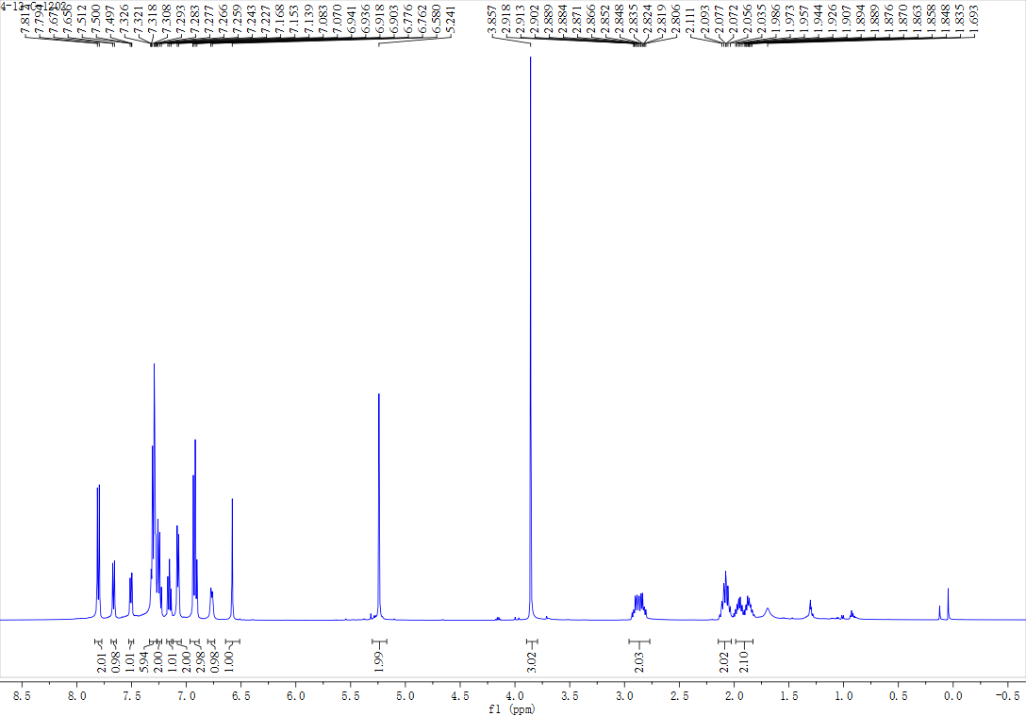



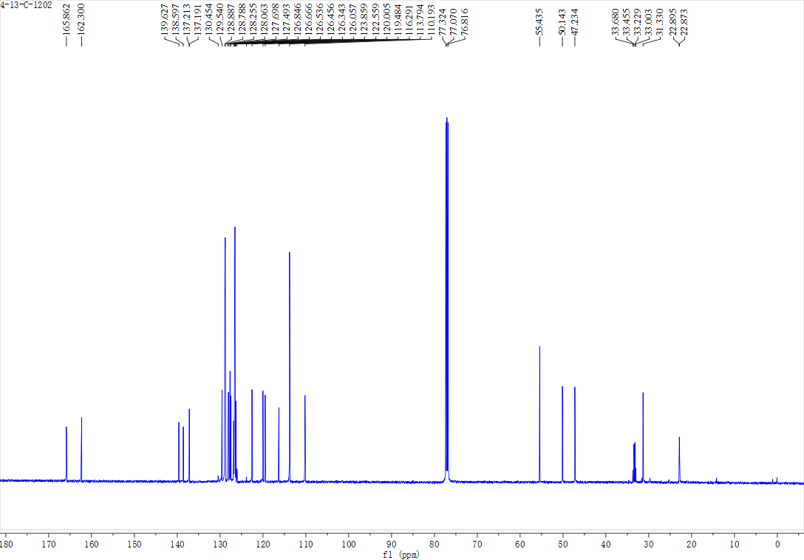



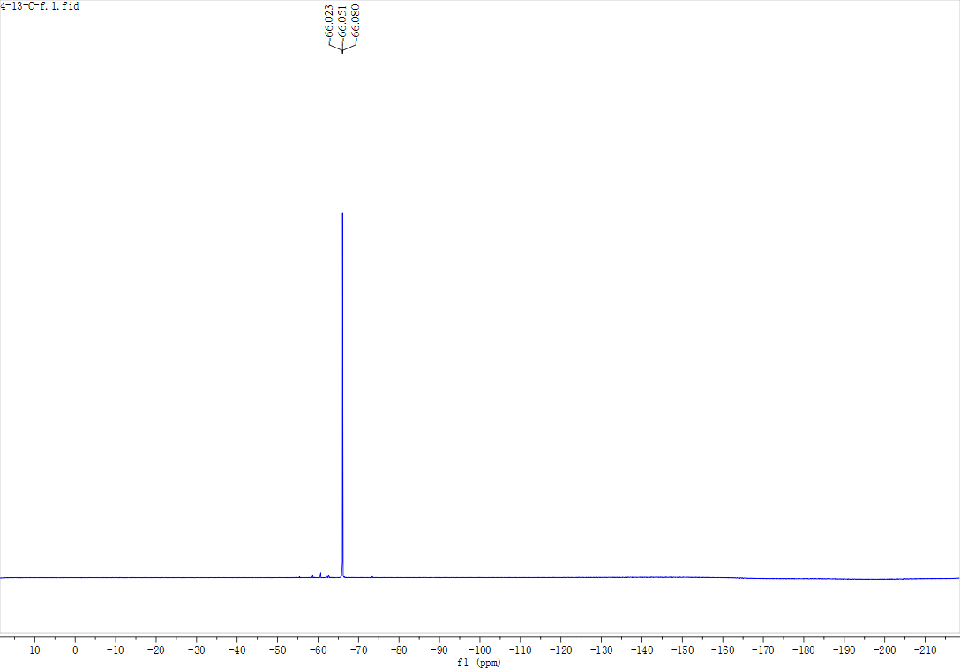



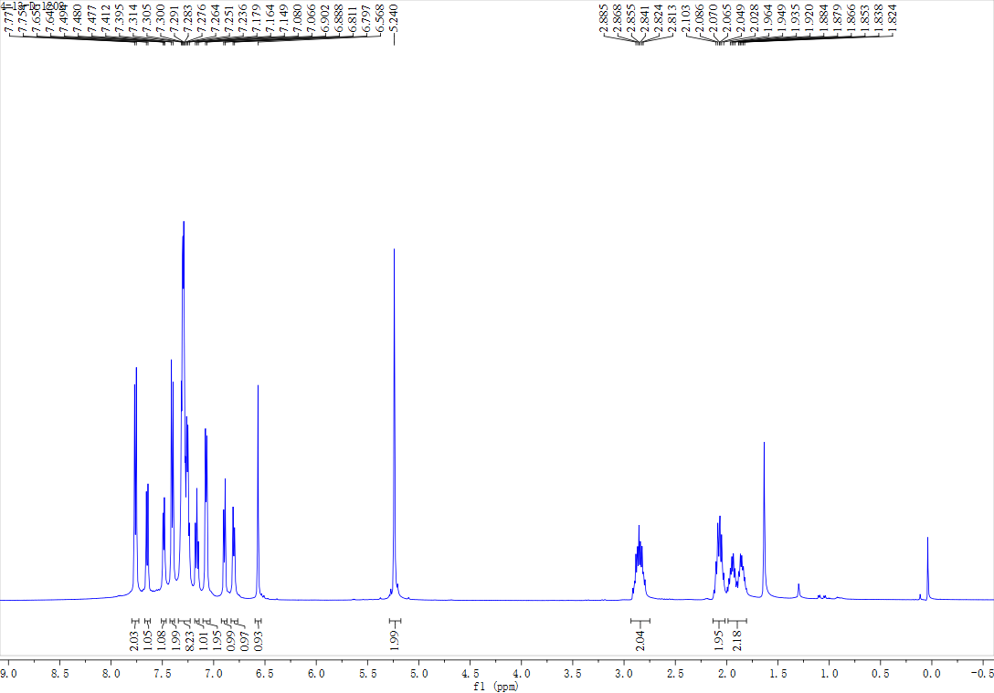



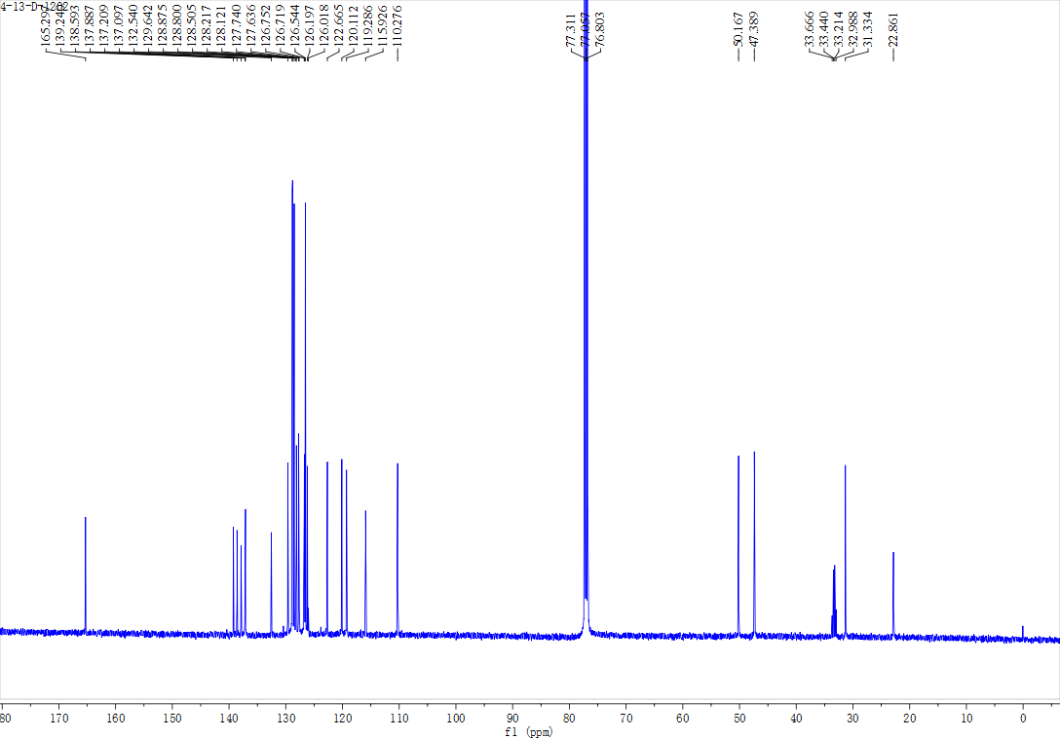



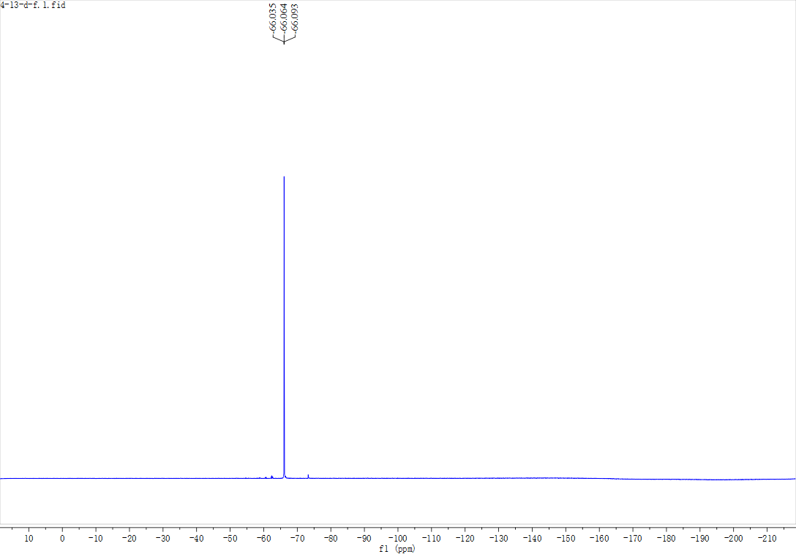



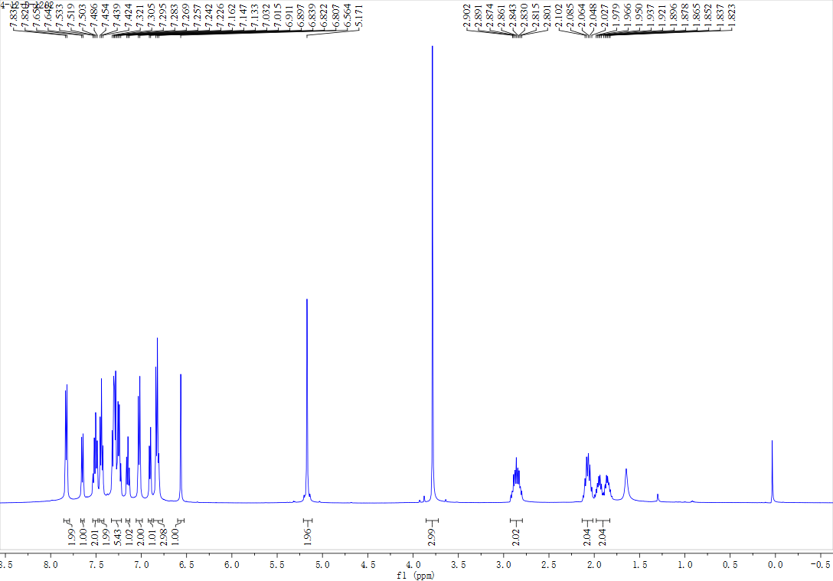



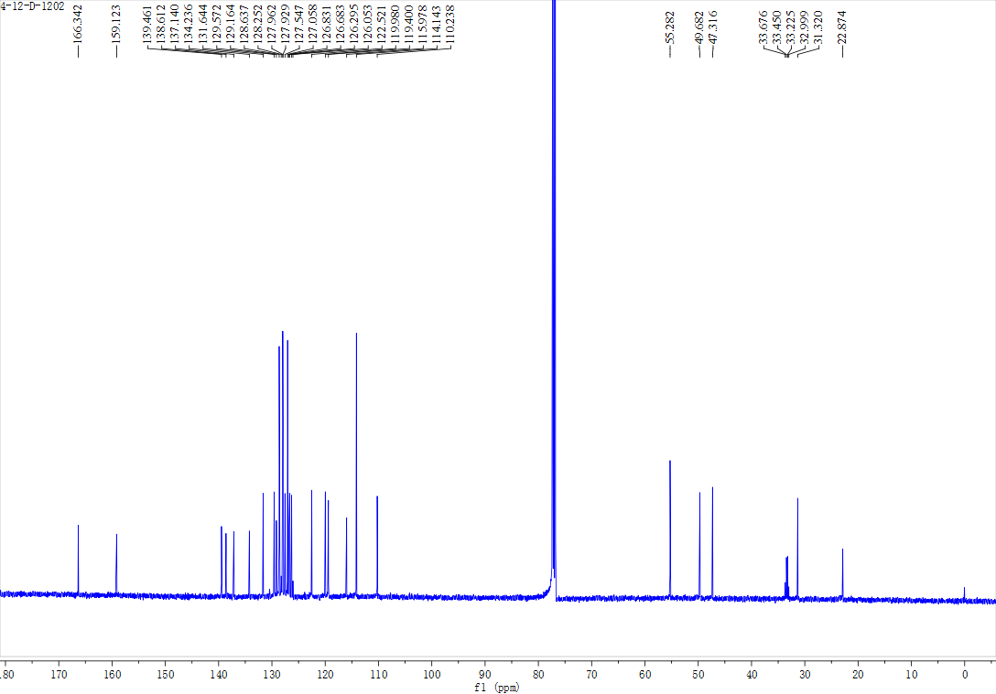



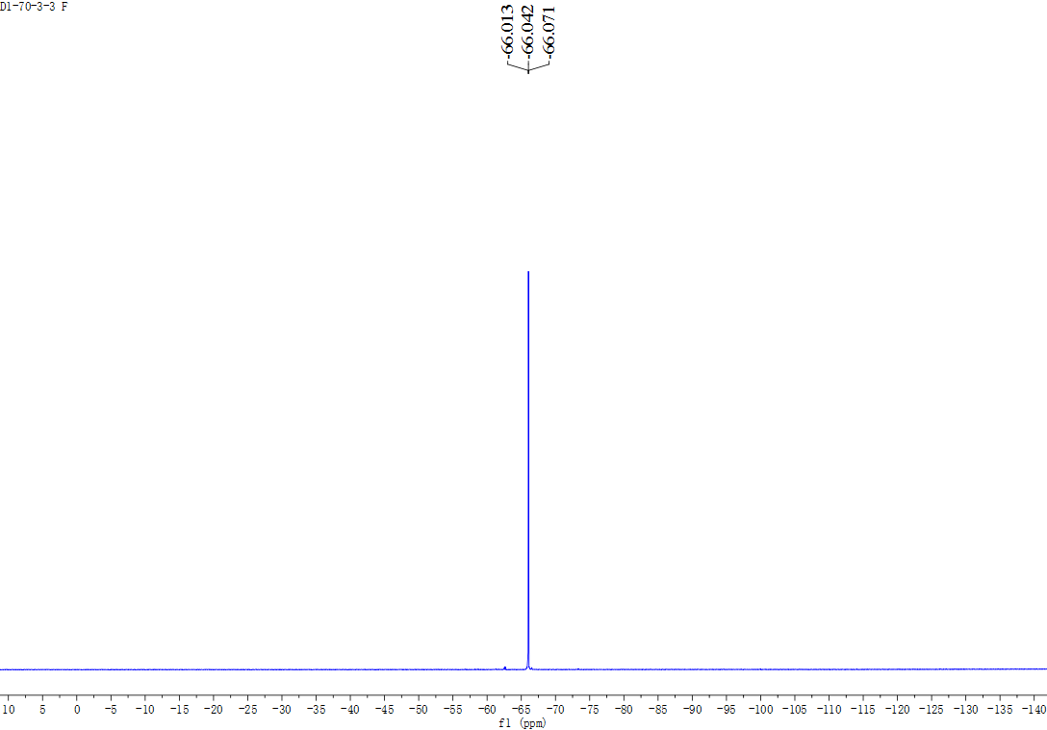



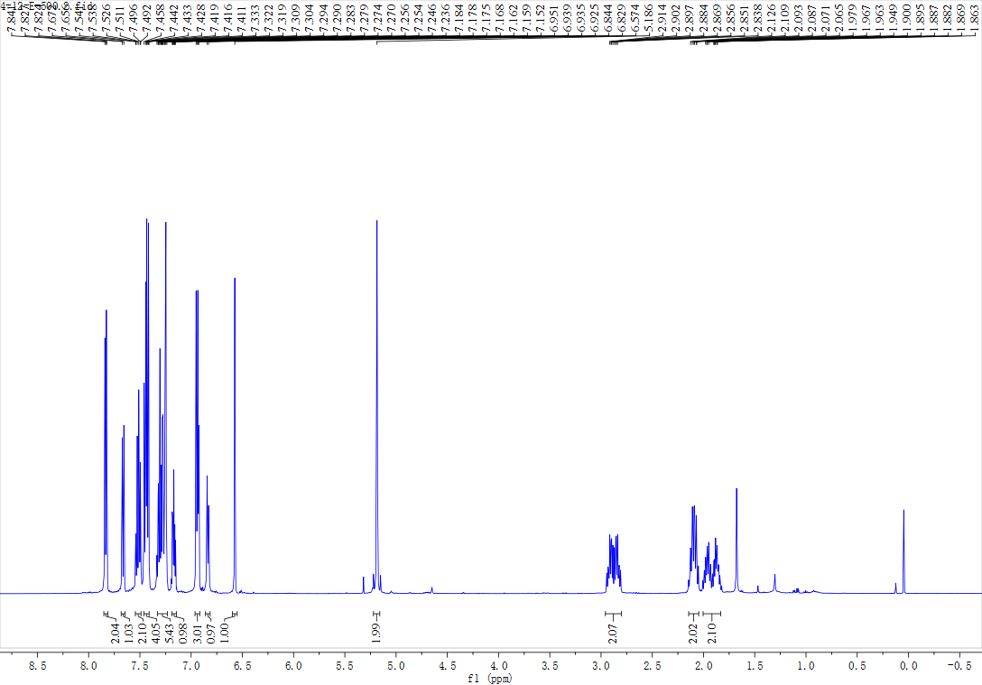



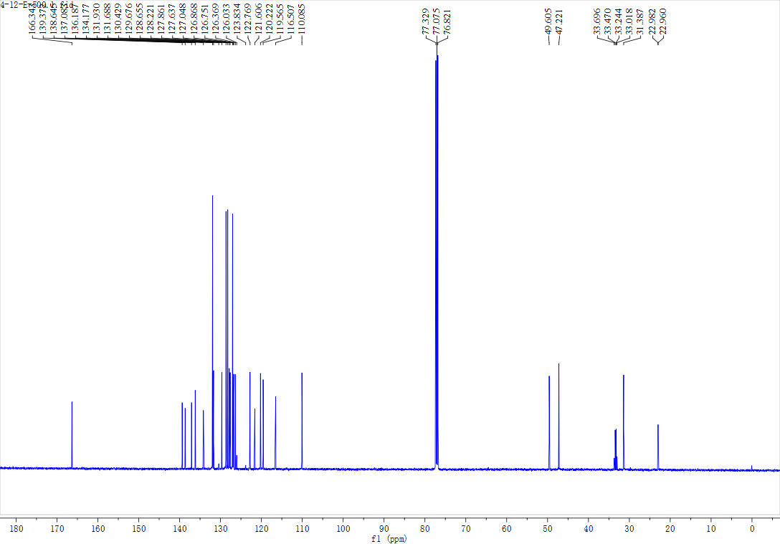



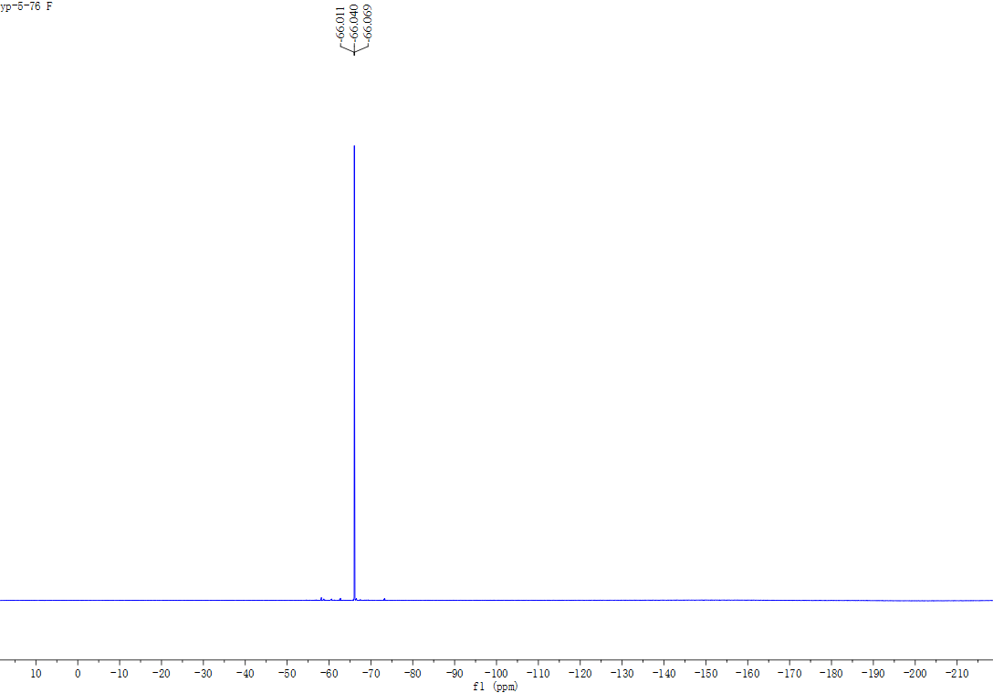



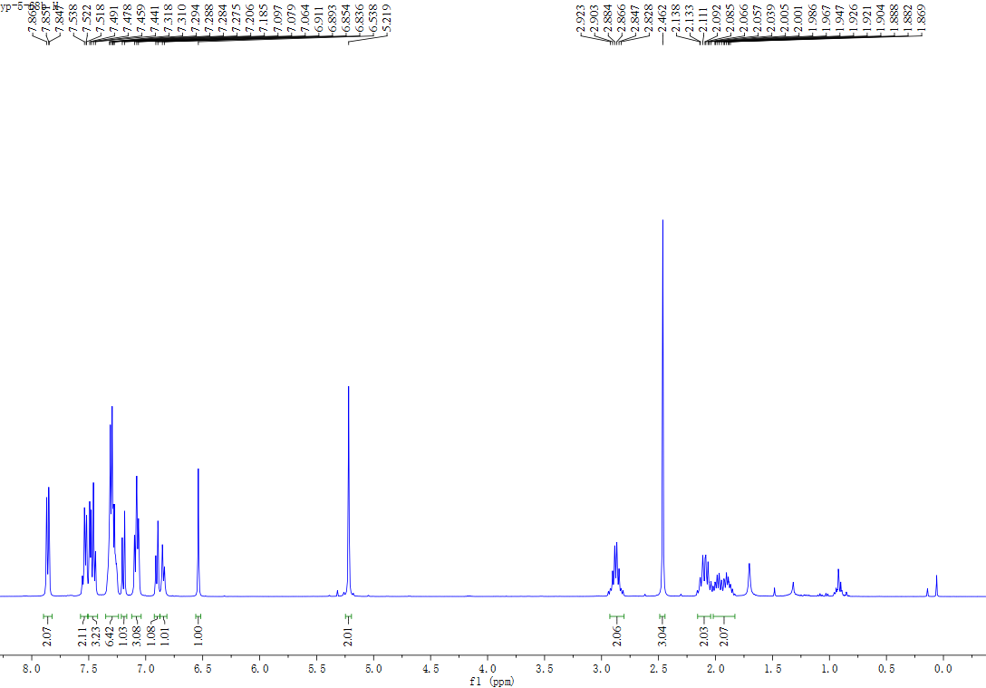



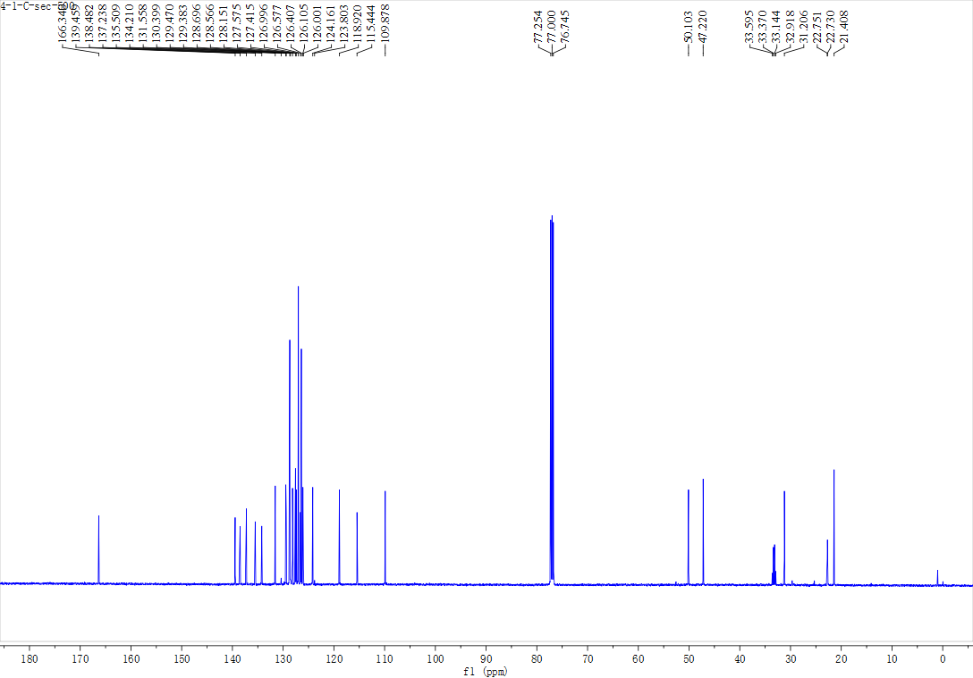



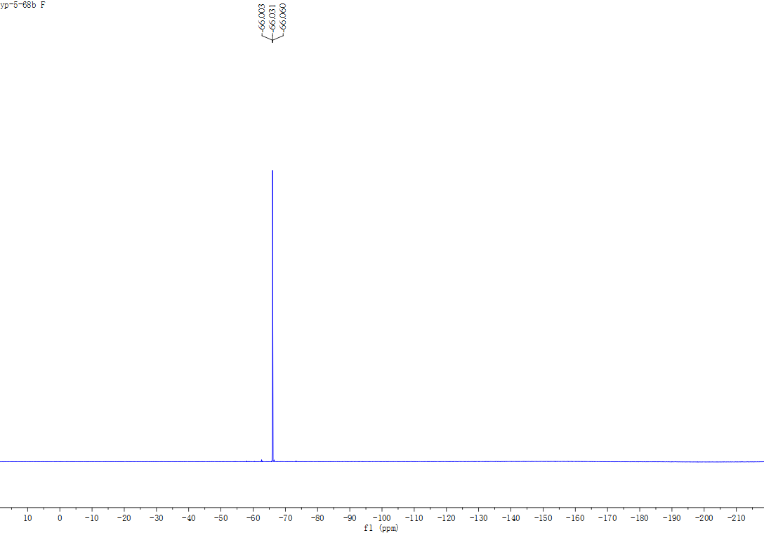



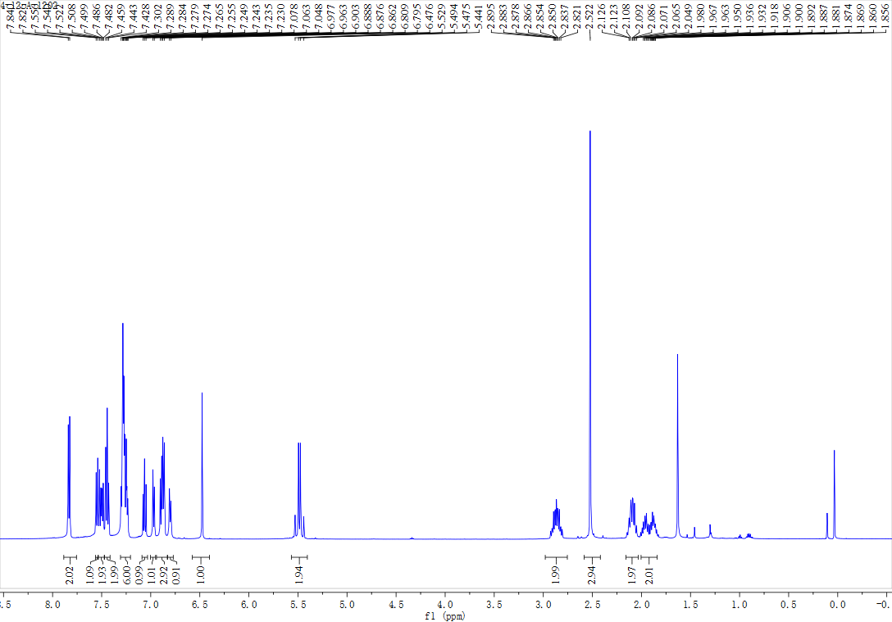



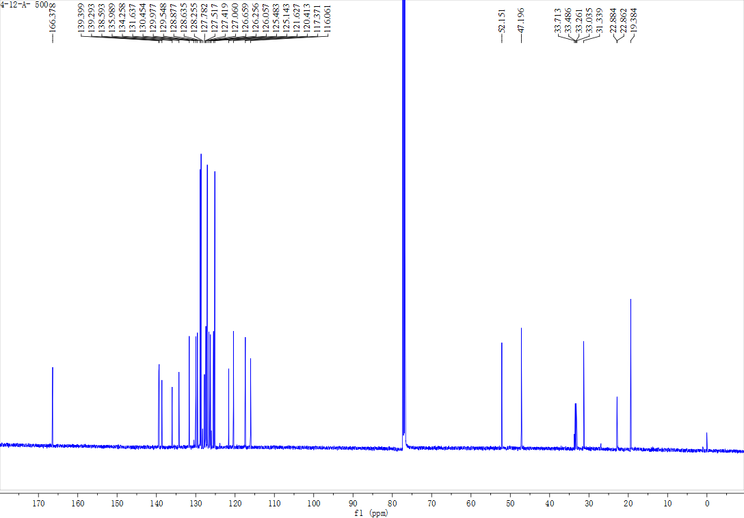



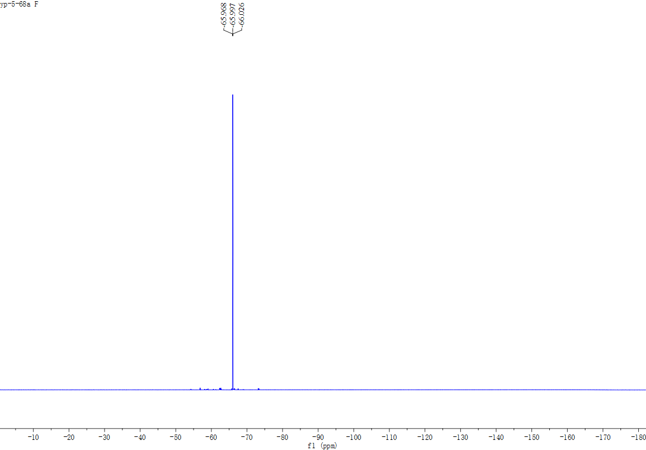



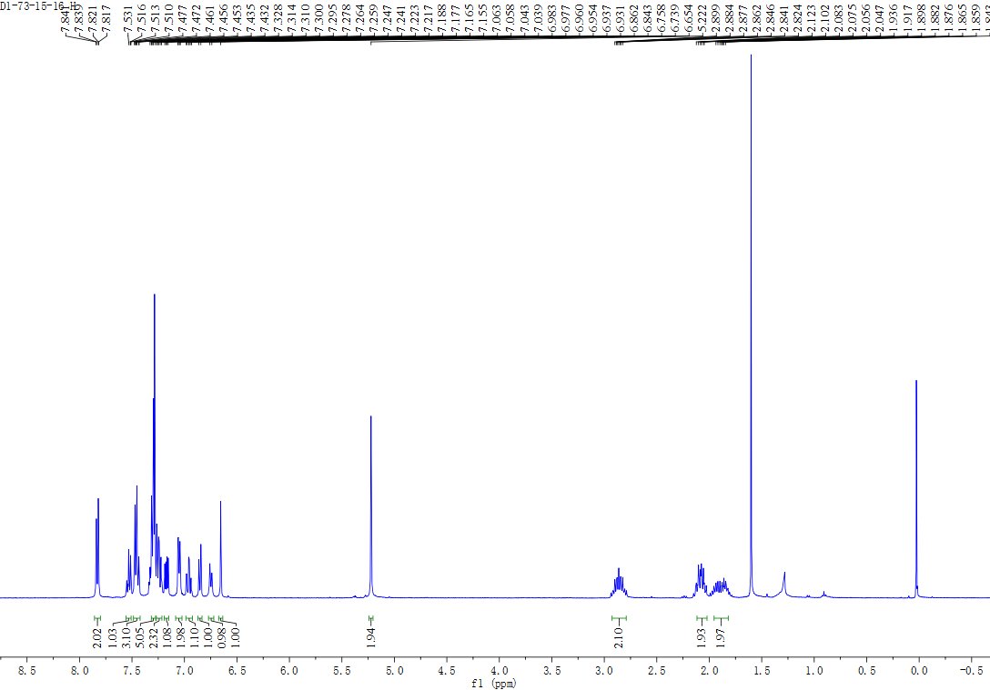



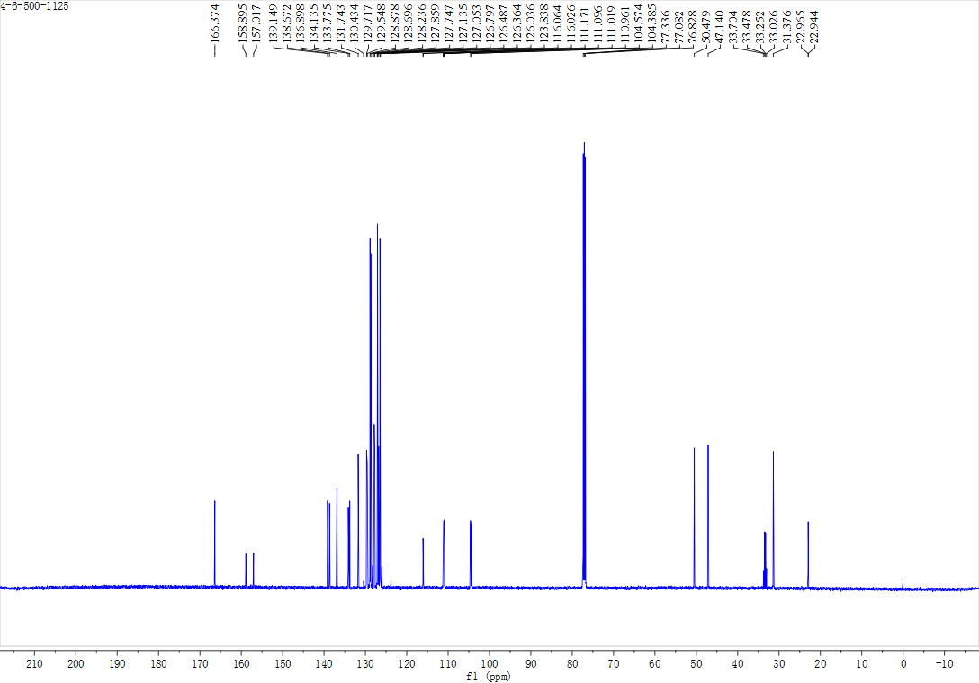



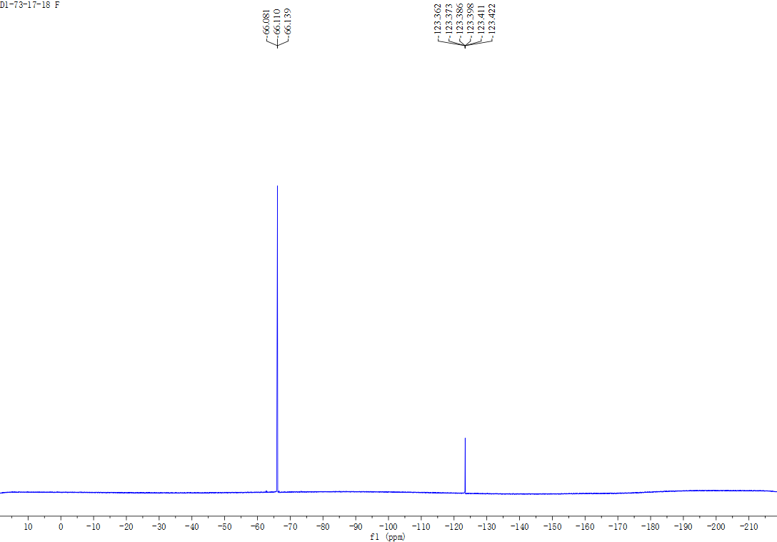



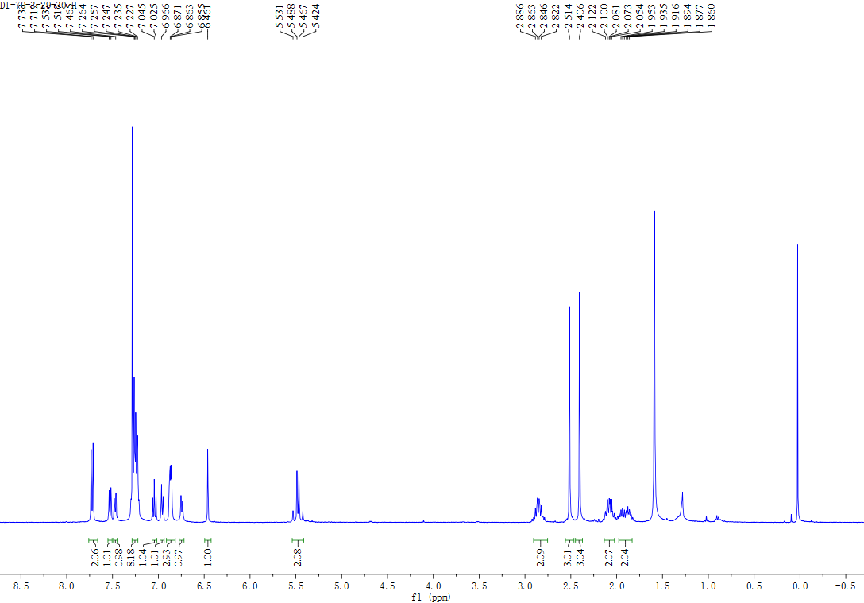



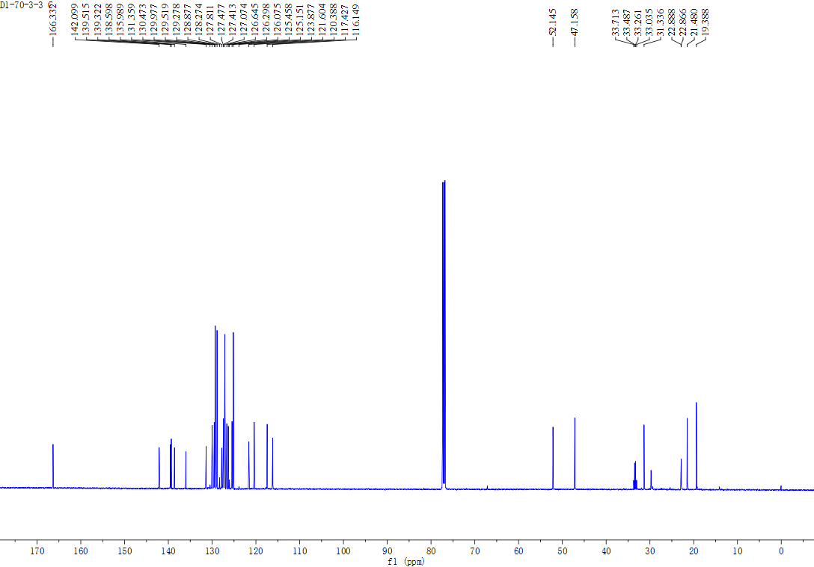



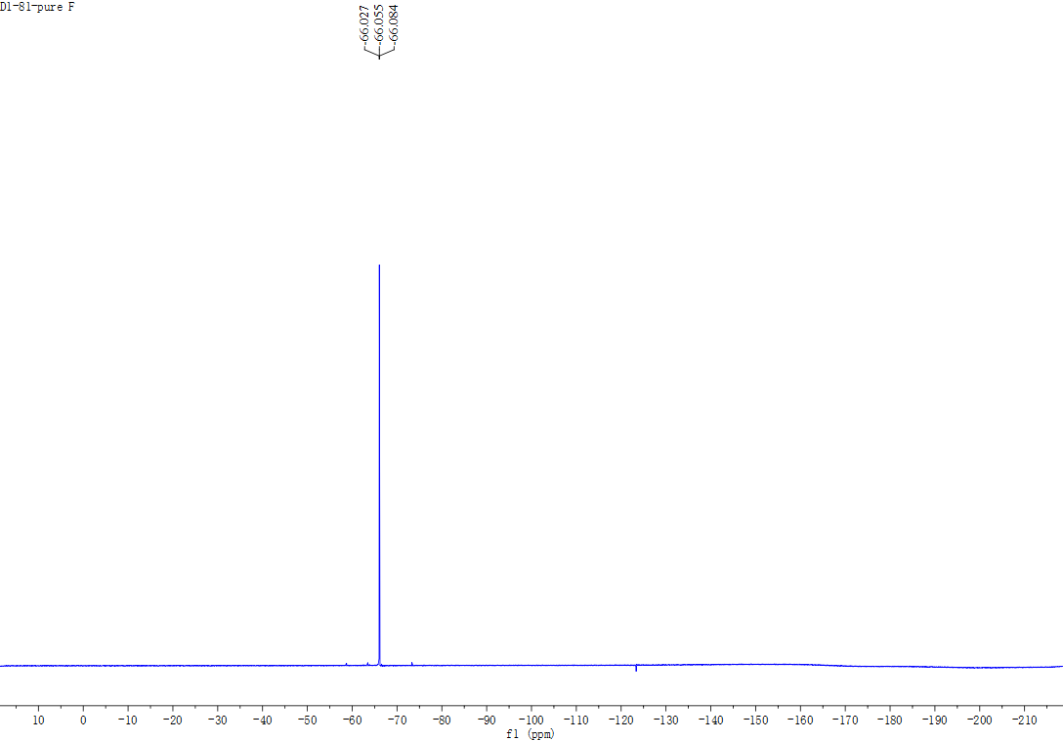



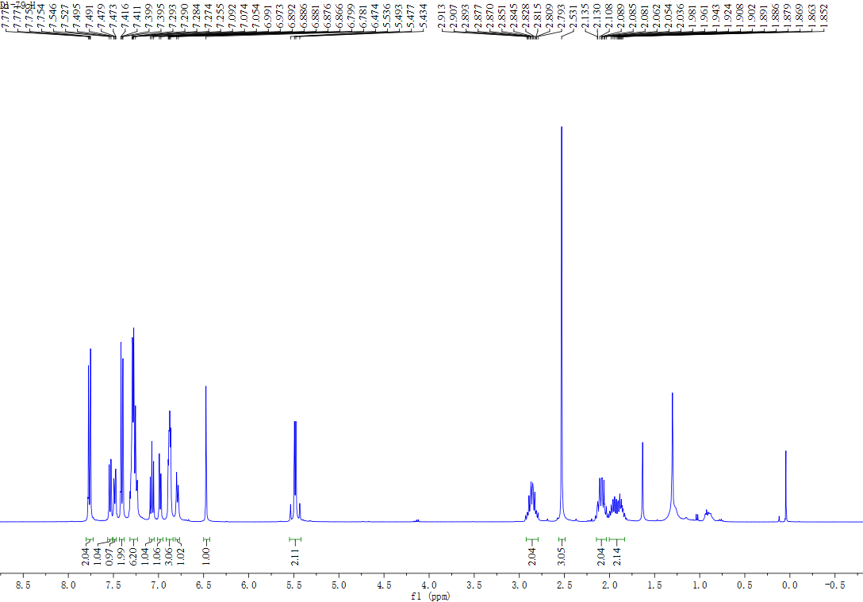



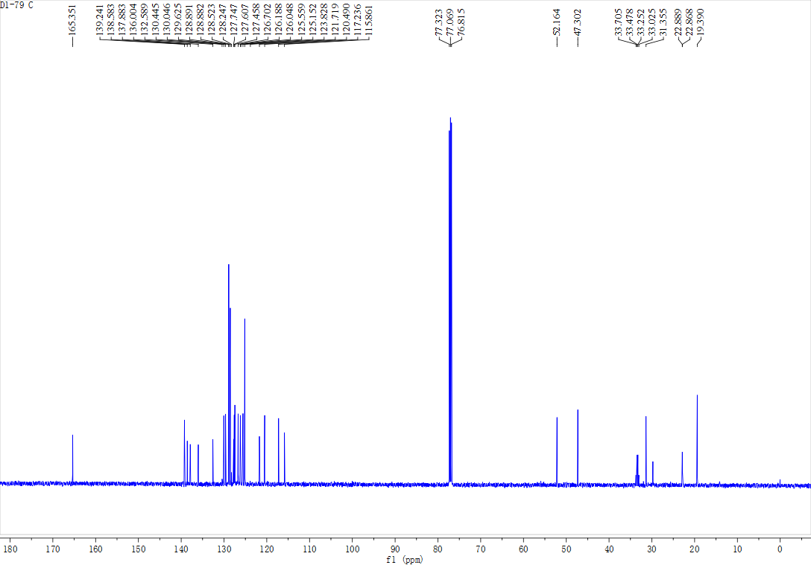



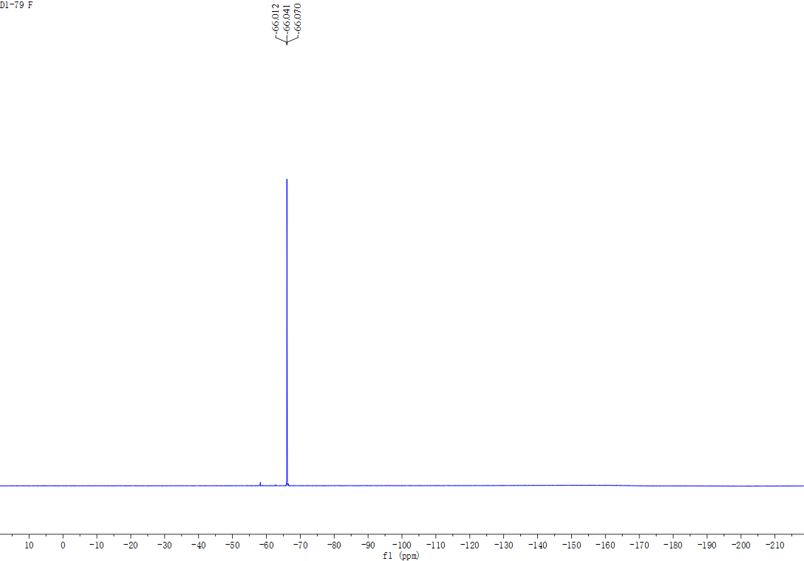



**HPLC Spectra**



